# Why use this template

# The goal of good paper writing is straightforward: to make your reader's job as easy as possible. there is no single, correct way to write a paper, and people develop their own methods as they become more experienced.

# Who should use this template

Everybody struggles with at least some aspects of writing a research paper for publication, some people more than others. This document offers a prescriptive method to write a paper in a stage-wise manner that is designed to make the process as easy as possible; this prescriptive structure is designed for people who new to the process. It is designed to get you started efficiently, before you eventually develop your own effective style. However, the document also offers advice on paper structure and on the writing process that may benefit people who have published work in the past and are looking for ways to make the paper-writing process more efficient.

# The paper writing process

Writing a paper can be done in a way analogous to building a house: start with a plan/outline of each section, then build the structure/framework of each section (e.g. start with one informal sentence for each planned paragraph), and only finally fill in the details (e.g. statistics, refinement of text/grammar). When building a house, you don’t start by fitting the carpets, as you will only have to replace them again. Similarly, when writing a paper, don’t work on the details (finalising figures, tables, etc.) until the end, as you will only end up re-doing them many times and wasting a lot of time in the process.

Importantly, allocate your time according to the importance of each section for communicating with the reader. This means: Title, abstract, figures. The title is read by far more people than the abstract, which is read by far more people than the bulk of the paper, and the rest of the paper receives far more attention than the methods (although this depends on the career stage of the reader: <http://journals.plos.org/plosone/article?id=10.1371/journal.pone.0189753>). High-quality figures that are easily understandable are an essential advertisement for the paper to people who are deciding whether it is worth committing their time to reading its details.

## Order of writing each section

Preparation and initial feedback

1. Complete initial analysis of the data and decide on what the main results and conclusions are.
2. Present results to other authors / peers. This will help to plan the results section and to help refine the conclusions. It will also reveal if further analysis is needed before the paper can be written.

Manuscript planning

1. Draft a title (and keep coming back to refine this as the paper progresses)
2. Plan abstract (and keep coming back to refine this as the paper progresses)
3. Plan Introduction section (paragraph headers, main points, e.g. as bullet points, not whole sentences just yet).
4. Sketch/plan rough figures/tables (e.g. in Powerpoint/Excel only to start with). Don’t try to transfer tabulated data into a Word document as this is a fiddly job best left until last, when you are certain the data in the table is correct (e.g. after any re-analysis).
5. Plan Results (do this before Methods, so that you know what Methods needs to include). E.g. brief descriptions of the obtained results as bullet points - these may become the section headers in the results section once you add in the details later. Each bullet-point / paragraph should have a defined role in advancing the story.
6. Plan Discussion. In reality, you will be adding information to the discussion section as you plan the previous sections (e.g. thoughts you have on interpretation, strengths and weaknesses of the design/analysis), and by the time you plan the discussion, you will be largely re-arranging the information you already have.
7. Plan Methods. This is last because it is the least-read section of a paper and its contents are informed by the other sections. Some journals even put the Methods section last in the paper, which reflects the common habits of the reader.

Manuscript writing (first full draft)

1. Write each section in the same order as you planned them (see above). Writing at this stage involves working on paragraph content and structure, but don’t spend time just yet on perfecting the *wording*, only perfecting the *meaning*. Wording can be refined once there is a complete draft. For example, if you find it easier at this stage to write in informal (non-scientific) language, which is often the case for people new to the paper-writing process, that is fine at this stage. Scientific language can be introduced and polished later on.
2. Produce figures/tables, but don’t perfect them just yet (i.e. no need to be publication quality). Keeping figures at low resolution for now, for example within a Powerpoint document, can be useful for sharing with other authors via email. Ideally, the figures (and legends) would match the structure of each section (Methods / Results) to make it easier for the reader to follow.

Manuscript refinement / re-drafting

1. One you have a first draft, create a “reverse outline” (<https://explorationsofstyle.com/2011/02/09/reverse-outlines/>) to tackle any structural problems, before working on refinements to the wording.
2. Work on the wording of each section. If you have written the first draft in informal language, here you can work on more formal scientific language. On the other hand, if you have written the first draft in overly complex language (e.g. long sentences, little explanation of complex terms), here you can work on simplifying the sentence structure and language as much as possible. Move very detailed parts of methods/results into supplementary sections. These simplifications makes the paper more accessible and more acceptable to high-impact journals that have more general audiences. It is important not to get too attached to one’s writing. Trashing entire paragraphs and rewriting is a faster way to produce good text than incremental editing.
3. Once you have a first draft you are happy with, get feedback from other authors and refine further. Of course, you will have been communicating the main ideas in the paper to other authors as you were going along, but this is the time to start sharing drafts of the actual paper/figures.
4. Get feedback from non-authors.
   * Start with verbally describing the paper to people not familiar with the work. If you, as the writer, cannot outline the paper to a colleague in a few minutes, then clearly a reader will not be able to get the main points in the paper either.
   * Then, get input from multiple people on the actual paper draft to make sure that the overall story works. They can give valuable input on where more or less detail is needed. They can clarify when it is best to go back to the drawing board and retell the entire story.
5. Perfect the figures and tables. This takes a long time to get right and makes a big difference to how the paper is received by readers, including reviewers. If crafted with skill and care, figures can boost the impact of your work nearly as much as the entirety of your text.

Journal submission

1. Reviewers provide extremely useful feedback. Non-specific feedback and apparently bored reviews usually imply that the reviewers did not “get” the big-picture storyline. Very specific feedback usually points out places where the logic within a paragraph was not sufficient. It is vital to accept this feedback in a positive way.

Preparation for REF review

1. Be aware that high-ranking papers are submitted to the Research Excellence Framework (REF). The paper needs to be written so that the REF panelists reading your work are clear on exactly what is *original* and *significant*, ensuring sufficient evidence that methods, analysis and interpretation are *rigorous*. REF review panels have only a short time to review each paper and so these three elements must be clear within the abstract and introduction.

Title page

# Title

…

# Short title

…

# Authors and Affiliations

…

# Corresponding author and contact details

…

# Disclosures

…

# Keywords

…

Main body

# Abstract

## Context

…

## Content

…

## Conclusion

…

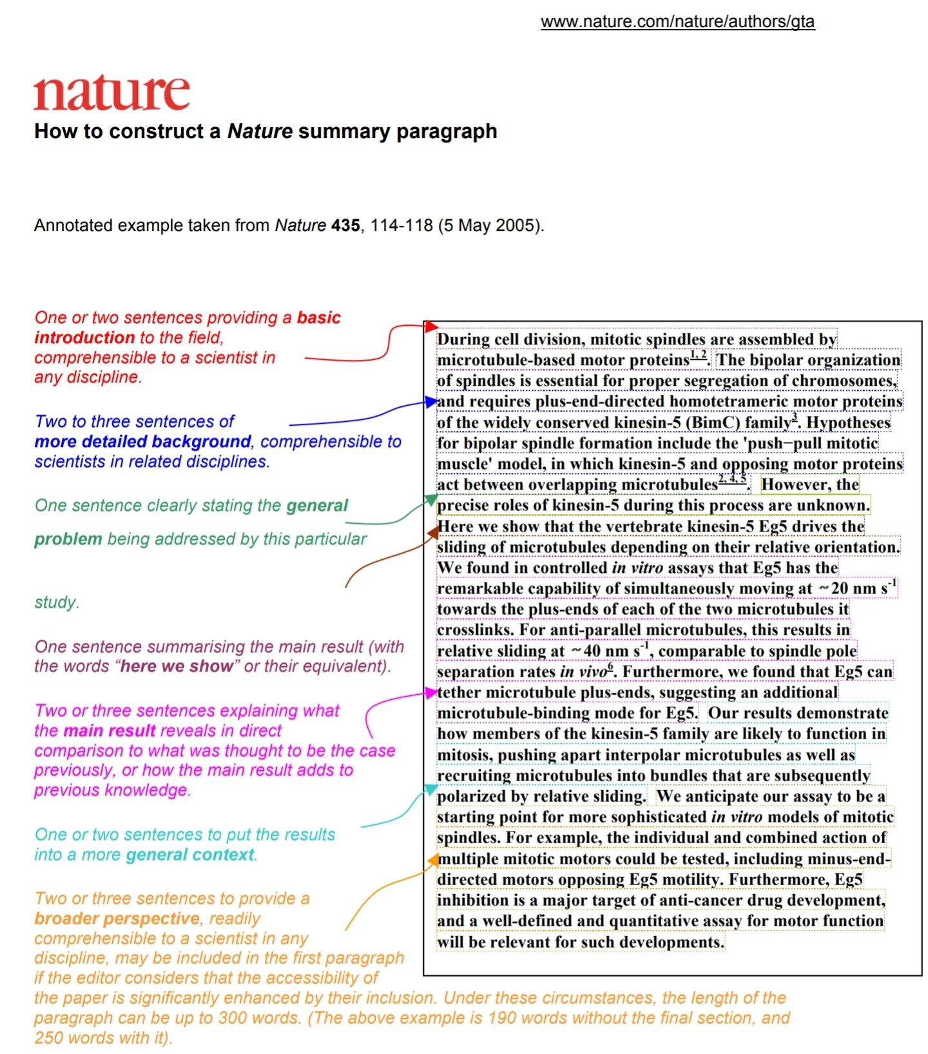

# Introduction

## Field gap

…

## Subfield gap

…

## Insight into the gap

…

## Summary of results

…

# Methods

## Study design and rationale

…

## Sample size determination

…

## Setting

…

## Participants and recruitment

...

## Study Procedures

…

## Data acquisition parameters

…

## Pre-processing

…

## Data analysis 1

…

## Data analysis 2

…

## Data analysis 3

…

## Data analysis 4

…

# Results: Structure

## Paragraph 1: Summary of approach

…

## Participants

…

## Subsequent paragraphs

### Data descriptions

### Figures and tables

# Supplementary Results

# Discussion

## First paragraph: Results summary (context)

…

## Subsequent paragraphs: Strengths and weaknesses (content)

…

## Final paragraphs (conclusions)

…

# References

Some advice on papers and figures that informed this template:

<https://www.biorxiv.org/content/biorxiv/early/2016/11/28/088278.full.pdf>

<http://onlinelibrary.wiley.com/doi/10.1111/ejn.13400/full>

<http://onlinelibrary.wiley.com/doi/10.1002/pro.514/full>

<https://explorationsofstyle.com/for-new-visitors/>